Establishing Silvopasture: A Mid-way Progress Assessment
John Fike,¹ Adam Downing²

Background

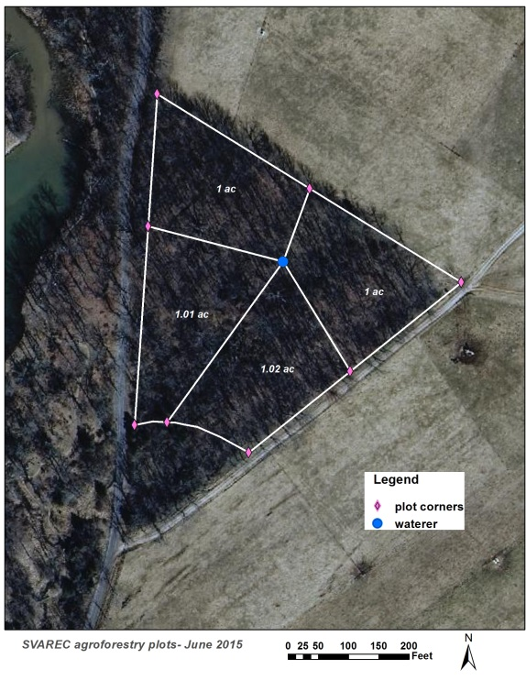
Silvopasture is the purposeful and managed integration of trees, forages, and livestock. With appropriate management, these intensive, integrated management systems create beneficial interactions among the system components that result in more efficient resource use and greater economic output over the life of the system. Benefits of silvopastures can include increased forage yield or quality, reduced animal stress, improved tree growth and quality, greater farm product and ecosystem diversity and a number of conservation gains (Fike et al. 2004).

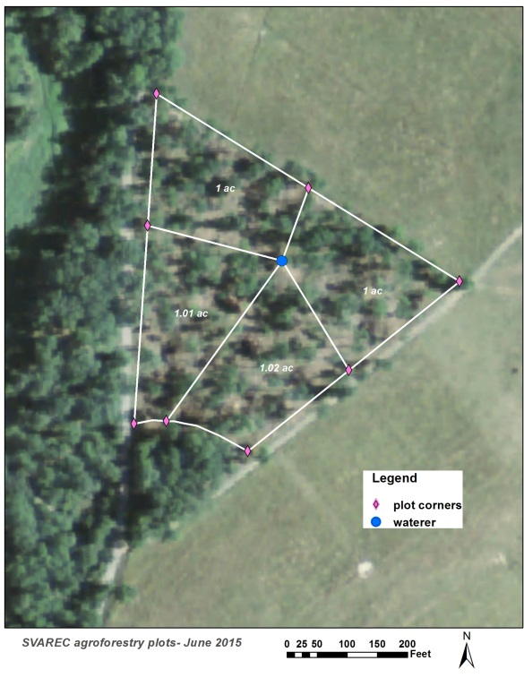
The intentional integration of trees and forages has been practiced in different parts of the world for decades or even centuries (Cubbage et al. 2012). In the U.S., this practice is most typically associated with pine systems in the Southeast coastal plain, but the practice is used in the Pacific Northwest under spruce as well as in hardwood growing regions of the country.
Demonstration site, pre- (top) and post- thin (bottom).
Images available from the Virginia Information Technologies Agency (http://www.vita.virginia.gov/isp/default.aspx?id=8412) and the FSA’s National Ag Imagery Program (http://www.fsa.usda.gov/programs-and-services/aerial-photography/imagery-programs/naip-imagery/index).

Silvopasture adoption by Virginia producers has been rather limited, especially in hardwood settings. However, interest and application of these systems is beginning to pick up. The potential benefits shown by early Virginia research, along with concerns for animal welfare, increased extension efforts, and the addition of silvopastures to the list of accepted NRCS conservation practices all are contributing to greater awareness of these systems. Because of Virginia's varied climate, soil and specific site conditions, the application of this practice on any given farm will differ.

This SVAREC silvopasture project aims to demonstrate how a degraded hardwood stand on a medium quality site might be converted into a mixed-use forage and timber producing silvopasture.

The goals of this project are to:
- improve the overall productivity of the site,
- provide shaded foraging/loafing for heat-stressed animals,
- provide long term timber value,
- remove invasive species, and
- maintain certain ecosystem benefits of natural habitats

Stand and Site Description

Prior to thinning, the wooded area was a mixture of various hardwoods namely green ash, black cherry, black walnut and hickory. Other species included: white oak, black oak, black locust, and American elm. The understory was dominated by non-native bush honeysuckle, multiflora rose, and spicebush. There was very little tree regeneration present. Along with an old home site, evidence suggests the area was pastured in the past, and some very large, mature white oak trees were present. The site (4.8 acres) had been fenced to exclude all livestock since the late 1990s. Most of the trees in the stand were smaller pulpwood sized trees, with an average diameter of 10.2”. The area was considered fully stocked (an indication of full site utilization).

Soils within this area are in the Frederick-Christian silt loam series. The area closer to the road is in the Frederick Rock-outcrop series. This soil type is derived from the weathered products of dolomitic and cherty limestone. This soil is typically fine in texture, rocky and very prone to erosion. Overall soil quality is moderately good in texture and fertility but several rock ridges run through the acreage making traditional forage management a challenge. This soil type is suited for growing fair quality trees, mainly black walnut, ash, black locust, yellow poplar, and eastern white pine. Average soil pH was above 6, with low levels of P, moderate K, and high Ca.

Forest manipulation

Prior to harvest, the site was a mixture of trees and invasive species such as bush honeysuckle and autumn olive. Thinning this site presented the opportunity meet our production goals both for timber and for forages and livestock while also removing a reservoir of invasive species seeds. While the thinning operation and subsequent site preparation (discussed later) removed many invasive species, follow-up treatments continue to be necessary to treat sprouting root systems as well as a few bushes that were too close to residual trees for large machinery to access.
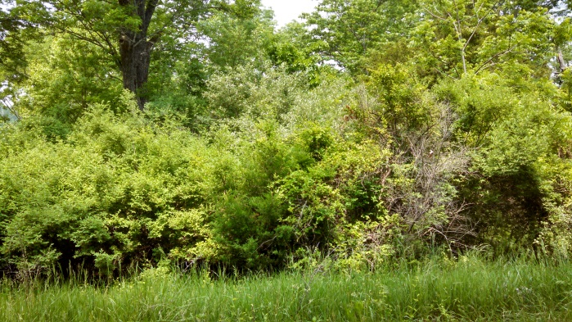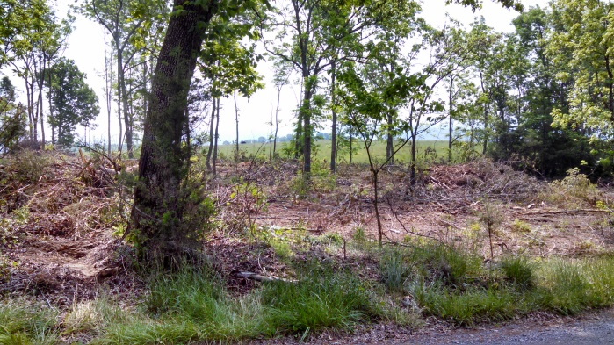
Visual condition: Pre-harvest Post-harvest

Finding a balance of the right quality and quantity of light to support forages under an overstory of partial tree shade is the aimed-for (and delicate) balance. To achieve this, the stand was thinned to approximately 50 percent of its current basal area. Basal area is a measure used to describe tree stocking in a given area, a sort of density measurement that accounts for tree size. Specifically, the basal area of a tree is the cross section of a stem (trunk) measured at breast height (4’ 6” above ground) and expressed in square units per area. Thinning to 50% of the original basal area is is generally considered a reasonable goal when converting hardwood forests to silvopasture (personal communication Tom Ward (NRCS, 2012).

The basal area of this site averaged around 100 ft² /acre. In choosing how many trees to leave behind, we considered three factors: species, stem quality, and spacing. Our goal was to leave well-spaced trees of suitable quality and characteristics and a residual basal area of about 50 ft²/ac (50% of 100 ft²/ac). Black walnut and white ash comprise the majority of the selected species. Of the 196 trees in the residual stand, 39% are black walnut and 25% are white ash. Following harvest, the residual stand’s average diameter was 9.8” (at 4.5 feet above the ground).

Along with producing nuts and high value wood, walnut has good silvopasture characteristics in terms of late leaf-out, early leaf-drop and a diffuse canopy. Such features allow more light to the forage understory. Ash has similar leaf shape and timing but is of lower timber value, so it is neither a preferred nor discouraged silvopasture species. The limitations of the site and the existing stand gave us these trees to work with. Both species are at risk for new non-native pests. Both the emerald ash borer and the thousands cankers disease of walnut are fatal pathogens and are currently present in various parts of Virginia. Neither is known to exist in Augusta or Rockingham Counties, though emerald ash borer is as close as Bath County. Data suggest thousand cankers may be present on most walnut trees but is not a lethal problem unless trees are subject to prolonged drought stress, and high degrees of recovery have been observed following return to normal precipitation (Griffin, 2014). Thus, site placement will be important if planting walnuts for silvopasture

Trees were evaluated before and after harvest to assess residual damage from harvest and clearing operations. Of the 196 residual trees, 20% received some sort of mechanical damage, which is acceptable by standard forest operations. This damage will be monitored for wound closure over the next several years but is expected to be an insignificant factor in overall vigor. Burning of brush piles resulted in some damage as well. One nice hickory was completely killed and a large relic oak was also severely damaged though this tree was already in decline and would not have had much market value. Two trees received damage to their crown from burning, 8 trunks were partially burned and 3 root plates received burn damage. The lesson here is that if burn piles are needed, keep them small and away from trees.

The most significant damage to the residual stand appears to be in response to the thinning. While thinning a forest can provide the “leave” trees with greater resources (light, water, nutrients) for growth, it can be stressful as well, especially when the stand is thinned heavily.
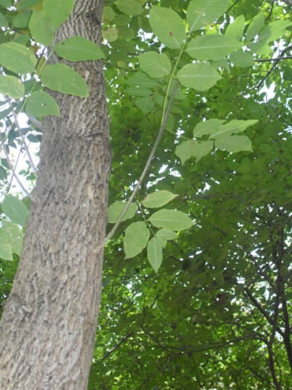
Epicormic sprout on white ash
Photo Credit: USFS
There are at least two concerns when supporting/sheltering trees are removed from the stand. First, if the crown or the leave trees are heavy and the trunks are weak, trees may be more sensitive to wind damage (either snapping or falling). This can be more of a problem for shallower-rooted species such as northern red oak and on sites that have little protection from high winds. Younger, more flexible trees also may be less sensitive to this type of damage in heavily thinned sites. So far we have had no loss due to wind throw.

Epicormic sprouting is a second concern. Sprouting is often a response to stress (see example in Figure).when forest grown trees are suddenly opened up, sprouting often increases because the heat from direct sun on tree boles/trunks, stimulates growth of otherwise latent buds that are under the bark. Epicormic sprouting can reduce timber grade on high quality logs, but this may be abated with tree selection – by leaving more dominant trees that are self-shading. As well, if the sprouts form higher up the trunk, this is better in terms of maintaining saw log quality on the “butt” log which contains the most volume and generally the highest value. At best, epicormic sprouting may have little or no economic consequence if there would never be opportunity to market the trees as saw logs. At its worst, epicormic sprouting may be a harbinger of a gradual decline in over-stressed trees. Time will tell how well we managed this aspect of thinning.

Implementation Schedule
Date | Season | Activity
2013 | June | Marked for harvest (marked keep trees)
2014 | Summer | Commercial harvest (removal of all non-marked material ≥ 2”)
 | August | Forest mulching on 2 acres (northern end)
 | September | Brush pushing (with skidder) and burning on 2 acres (southern end)
 | October | Hardwood sprout control, on “pushed” 2 acres with 2% Garlon 4
 | Early November | Broadcast forage mixture
2015 | 23 April | Spot reseeding of forage mixture in bare and light areas
 | 14 May | Herbaceous weed control, 4 acres with Banvel 1 pint/acre

Forage introduction

Prior to seeding, the site was divided in half, with the northern half receiving a “forest mulching” treatment and the southern half receiving a more traditional “pushing” type with the blade on the log skidder. The objective of both was to create a suitable seedbed for grass seed by removing or masticating any remaining slash and woody debris.

The forest mulcher is a machine similar to a stump-grinder but with teeth on a drum, rather than a disk and mounted on the front of a skid-steer like machine. This turns wood material (dead or alive) into woodchips/mulch. One benefit of this method is the retention of organic matter on the site rather than lost to burn piles. In this case, some burn piles were also created as mulching everything would have resulted in mulch 3-4 inches thick… too thick to sow grass seed over and expect it to achieve contact with the mineral soil.

The more traditional method of pushing brush into burn piles does not necessarily require special equipment and in this case simply used what was on the site, the timber cutter’s log skidder with the basic 6 foot non-articulating blade. A risk with putting a blade to work on agronomic land is the potential disturbance and loss of top soil. Being careful of this, the skidder operator moved the bulk of the woody debris but enough was left behind we used manual labor to additionally clean-up the site with picking up residual slash and woody debris and adding them to burn piles.

Original intent was to plant one or two cool season grasses, but we have little information about forage species suitability within shaded sites. Thus the decision was made to plant a blend of species – but it took time to get the seed, so this delayed the planting until early November.

The seed mixture included:
- ‘Select’ endophyte free tall fescue
- ‘Benchmark’ orchardgrass
- ‘Remington’ perennial ryegrass
- ‘Baron’ bluegrass
- ‘Pradel’ meadow fescue.
Each forage species was seeded at 5lb/acre along with cereal rye at 10 lb/acre (totaling 40 lb/acre). Shade tolerance of these species is not well known and may vary by variety within species, so this seeding is a bit of a “stab in the dark”. Meadow fescue has high digestibility and is considered to have relatively good shade tolerance. Reed canarygrass is another shade tolerant species of interest, but seed of low alkaloid varieties were not available for planting.

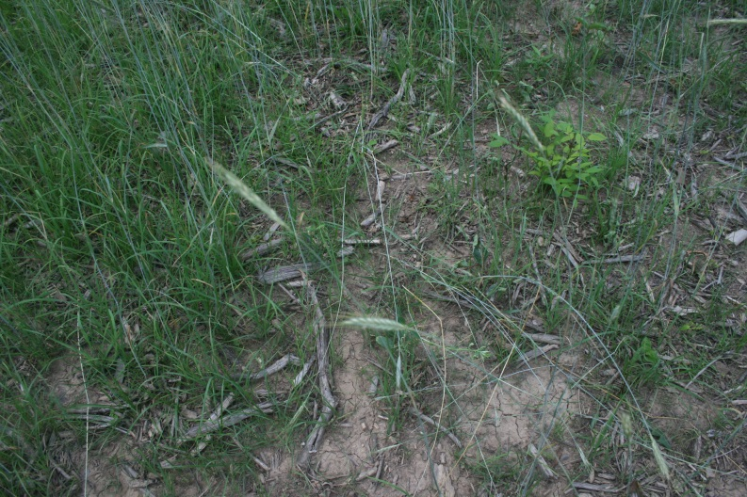
The late seeding was problematic and may have contributed to some of the weed pressures observed this spring. Because grass seedlings were newly emerged and facing competition with broad leaved herbaceous and wood vegetation, we treated the site with Banvel (a selective herbicide that does not kill grass at low concentrations). Cheat grass in portions of this site may be a future challenge. Cheat is a cool season annual that creates a significant mat, at times overwhelming grass seedling establishment. An earlier planting may have reduced cheat competition. Empirical observations from this and other sites suggest that cheat may be a problem where soil N is low. This sometimes happens under walnut trees because walnuts may reduce forage legume populations. Long term, we may test different legumes to see what works best in these systems.
Possible increased seedling recruitment where “mulch” caught and held seed.

Seedling recruitment also was challenged by the broadcast application. A grass drill places grass seed in good contact with mineral soil but was not possible in this site with rocks and stumps. A possible alternative in certain settings is to introduce livestock to work seed into the ground. That was not feasible in this case because fence and water infrastructure were not in place. We do think we are observing better seed establishment where the site was mulched. This may in part reflect greater weed control, but likely the improvement reflects that seed “catch”, falling into (and staying in) contact with soil.

Citations
Cubbage, F., G. Balmelli, A. Bussoni, E. Noellemeyer, A.N. Pachas, H. Fassola, L. Colcombet, B. Rossner, G. Frey, F. Dube, M. Lopes de Silva, H. Stevenson, J. Hamilton, and W. Hubbard. 2012. Comparing silvopastoral systems and prospects in eight regions of the world. Agroforestry Systems 86: 303-314.
Fike, J. H., Buergler, A. L., Burger, J. A., and Kallenbach, R. L. 2004. Considerations for establishing and managing silvopastures. Online. Forage and Grazinglands doi:10.1094/FG-2004-1209-01-RV. Viewed July 5, 2013. Available at http://www.plantmanagementnetwork.org/pub/fg/review/2004/silvo/
Griffin, G. 2014. Status of thousand cankers disease on eastern black walnut in the eastern United States at two locations over 3 years. Volume 45, Issue 3. Online. Forest Pathology. Viewed July 1, 2014. Available at http://onlinelibrary.wiley.com/doi/10.1111/efp.12154/full

Appendix
The following brochures, articles and factsheets are available from the USDA National Agroforestry Center: http://nac.unl.edu/silvopasture.htm
- What is silvopasture?
- Mitigating Heat Stress in Cattle
- Agroforestry Notes
  - The Biology Of Silvopastoralism
  - From A Pine Forest To Silvopasture
  - From A Pasture To A Silvopasture System

Authors
¹ John Fike, Ph.D., Forage-Livestock & Biofuels Extension Specialist, Virginia Tech, College of Agriculture and Life Sciences
² Adam Downing, Forestry & Natural Resources Extension Agent, Virginia Cooperative Extension, Northern District

